IFHE NEWSletter Issue 2016/2 May2016
IFHE reserves the right to edit, abridge, or otherwise alter material included in the Newsletter. The views expressed by contributors of articles, or in quoted extracts, are not necessarily those of the International Federation of Hospital Engineering, and are published with no acceptance of responsibility for stated opinions or allegations.

Presidents Column May 2016

OBJECTIVES, PRIORITIES AND POLICIES
Echoing the last period I also establish seven objectives for my Presidency of the IFHE:
- Improve the meeting and contact moments between the IFHE Members, Exco, Council and several Working-groups.
To the pace of work in the various (working) groups we have to improve the contact moments. At the beginning of the calendar draw up an agenda with all meeting times. With the aim to increase the productivity
- Encourage the quality of working-groups.
The working-groups indicate when any product is being supplies.
True a planning progress is monitored. The results are shared with IFHE members though newsletters sent by mail and the Digest.

- Expand the current scope of IFHE to new countries, other societies and scientific institutions.
New countries, some to go in Europe, continue Latin America, extra focus on Asia
Agreements are being elaborated with WHO, PAHO and UIA.

- Enhance and improve the tools available at IFHE to serve its members.
IFHE current publications (Newsletter, IFHE Digest) merit a renewed impetus, and the Digital Library shall continue to be updated and enriched.

- Environmental Sustainability.
- To follow the objectives written in the IFHE Environmental Policy ver1.0 01-juni-2015.
- work set to achieve the objectives
- Raising sponsor money to build more supportive projects
- To have more decisiveness in setting up projects, sponsorship money is needed.
- Cooperation with development organizations strengthen our decisiveness.
- Recruiting grants.
- Promote an accreditation for engineers in HealthCare.
- The realization of a professional recognition for technicians.

Douwe Kiestra. 17-04-2016


  NVTG IFHE World Congress 2016: Epilogue
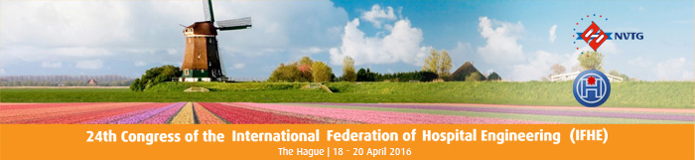
Dear IFHE and NVTG members,
We have had a great congress on hospital engineering on 18 and 19 April 2016 in the World Forum in The Hague. We have realized our dream of, as the Dutch association of technology in healthcare (the NVTG), organizing the twenty-fourth congress of the International Federation of Hospital Engineering, (the IFHE) in 2016. It was an honor to welcome our international colleagues in The Hague in The Netherlands, because we had clear ideas as to how to share knowledge for better healthcare worldwide. Last week the congress took place and it were the attendees who made it a fantastic event.
We were all together with 930 participants from 37 different countries and we have seen 120 business partners at the exhibition stands and 35 key-note speakers from 12 different countries.
The 25 key-note speakers were key in delivering the participants a relevant state of the art program of high quality key-note presentations with very interesting subjects that gave us new insights and new ideas, or that confirmed the benchmark that the existing ideas were still excellent and highly relevant for the future. We learned to put our daily work in an international perspective, we learned from cultural differences and we were able to share our networks and knowledge worldwide

Speech by Director-General of Curative Care Van Den Dungen
Ladies and gentlemen,
Today you were expecting minister Schippers. Unfortunately, there is no job as uncertain as that of minister. You intend to attend a congress – and then, all of a sudden something very important intervenes. That is what happened this time as well. The minister was looking forward to presenting this speech to you, however one week ago it proved impossible for her to do so today. That is why I am here now. My name is Bas van den Dungen and I am the Director-General of Curative Care – Minister Schippers’ right hand when it comes to hospital care.
A healthcare institution nowadays is very similar to a high tech industrial complex. Upon entering you are amazed by all the technical gadgets there: Hospital beds that send a signal when there’s a chance that the patient might fall out of bed, transmitters that track dementing elderly people when they tend to wander off, I could talk for hours regarding these kinds of innovations.

Papers
The presentations of the lectures given by the key note speakers will be published on http://www.ifhe2016.info/papers
.All presentations will be published as soon as permission is given by the author(s).

Technical Visit Programme A: Hospital Tour Erasmus Medical Centre Rotterdam and Reinier de Graaf Hospital Delft

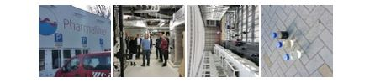

EGM Architects was selected to organize the program for the technical visits to the cure sector.
The Erasmus M.C. and Reinier de Graaf Hospital were eventually visited by 100 attendees of the NVTG IFHE World Congress 2016. The participants were split into two groups during the visit, in order to keep the maximum number of visitors per hospital at 50. This way, the disturbance of the working processes in the hospital could be kept to a minimum. Both hospitals used qualified personnel of their own to provide the visitors with proper guides through the hospital and to maximize the sharing of knowledge. The guides guided the visitors to different but all essential sections of the hospitals and were able to provide many answers to the questions of the visitors. After the morning program, a delicious lunch was served at the hospitals by EGM, after which the groups switched hospitals

Technical Visit Programme B: Gemiva-SVG Groep

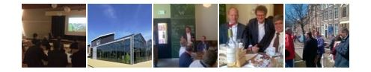

It’s Wednesday, April 20th. After two days spent inside the conference rooms of the World Forum in The Hague, this day was all about the Technical Visits. Upon registering for the congress, participants could select this extra option and choose between a cure tour to the Erasmus M.C. and Reinier de Graaf hospital, or a care tour to the Gemiva-SVG group.
At 8.30 in the morning, the group (with 25 international participants) left for the Gemiva-SVG Group. Gemiva-SVG Group is located in the Dutch province of Zuid-Holland and supports people who as a result of handicaps, chronical diseases or other limitations have a need for care or guidance.
At 9.15 in the morning we are welcomed at the first location Swetterhage in Zoetermeer.
On the way over, one of the international visitors is asked why he chose the care tour instead of the cure tour. His answer is that this way he gets to see such a beautiful part of the Netherlands. He is right. It is a lovely day, and along the way we get to see old and new windmills, high waterways and lower meadows. Read more..

Cultural Visit

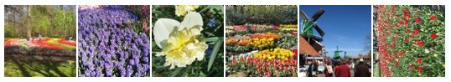

Thursday April 21st was the very last day of the congress.
After days of lectures, engineering and visiting different locations, this day was all about relaxation.
On this day, we wanted to show our international guests a bit more of The Netherlands.
With the sun shining high, it proved to be a great day to give our guests a good impression of the all the beautiful things The Netherlands has to offer. The bus once again departed at 8.30 in the morning from the World Forum in The Hague with a total of 40 participants. The journey went through Wassenaar and Noordwijkerhout, thus providing the participants with a good impression of the Dutch way of life.
After a short trip, the participants arrived in the Keukenhof, and they could not have picked a better day. As described earlier, the sun was shining brightly and all the flowers were in full bloom.
This of course was much to the joy of the congress commission, as no one (not even the congress commission) can influence the weather and the blooming of flowers.

Photos

During the congress multiple pictures were taken.

IFHE LIBRARY AWARD 2016 / PRIZES WITH TROPHY AND CERTIFICATE

FIRST PLACE PRIORITIES FOR BIRTHING ROOMS VENTILATION SET OUT
Authors Phil Nedin (the.nedins@btinternet.com )
C. Engineer, IHEEM Past President, Consultant Engineer-London
Dr Anna Coppel,
C. Engineer ,Arup’s Advanced Technology and Research –London

Phil Nedin, and Anna Coppel, describe a design analysis that used computational fluid dynamics (CFD) to investigate and validate the effectiveness of a number of mechanical ventilation options often associated with birthing rooms, thereby ensuring a system that is fit for purpose. In such settings, they point out, the need to reduce the levels of nitrous oxide to a COSHH threshold is a legal requirement. A high level technical research and extensive analysis very well documented . A good technical article of interest to the whole world.

SECOND PLACE THE PARADOX OF A “GREEN” CLINIC IN THE HEART OF A COAL MINE
Author/s Ernesto González Nagel ( ernesto.gonzalez.nagel@gmail.com )
Joao Athayde e Melo
Architects
Institute of Science and Technology of Mozambique, Maputo

A very good paper, describes a project in the developing world with clearly defined strategies. In response to the harsh tropical climate that enhances coal dust in the air, the concept of the project was to create a comfortable and healthy microclimate via sustainability: correct building blocks orientation, use of local stone and wood, collection of rain water, natural ventilation and cooling, strategically placed openings in walls and roofs, water heating with solar panels, water pumping with energy from a photo-voltaic system, use of solar fiber optic system combined with LED, naturally filtered air by the creation of a wood/stone/coal/water filter.. The careful articulation of open air, segregated, technical and public corridors and patios, under the protection of a wide roof, with water and vegetation, makes the Clinic's space an integral instrument for preservation of health and wellbeing.

THIRD PLACE BIOMASS FROM FOREST ORIGIN AS A RENEWABLE ENEGY SOURCE IN HOSPITAL POWER PLANTS
Authors José Luis López González (jluis.lopez.gonzalez@sergas.es).
Engineer (Hospital LucusAugusti de Lugo), Máster en Arquitectura Sanitaria, Member of the Board of the AEIH Spanish Association
Antonio Taboada Prado (antonio.taboada.prado@sergas.es).
Engineer, SERGAS, Xunta de Galicia- (Conselleria de Sanidade)

The Galician Health Service has elaborated a sustainable and efficient Energy Plan . Within it, the Ecospital Plan comprises a renovation of nine hospital power plants to incorporate as renewable energy source the residual biomass from forests. The fact of enhancing the consumption of biomass from forests in the region is particularly relevant to contribute to give value and usefulness to forest residue, reducing the risk of forest fires, and ultimately providing greater added value to the forest wealth. Important project on sustainability from different approaches, demonstrating the viability of the biomass application as renewable energy source in hospitals

IFHE LIBRARY AWARD 2016 / CERTIFICATE FOR HIGHLY COMMENDED ARTICLES

EFFICIENT MANAGEMENT AND REUSE OF WATER FROM DIFFERENT PROCESSES IN A HOSPITAL
Author/s José Carlos Cardillo Lorente (jcardillolo@saludcastillayleon.es)
Luis Mariano Bocos González (lbocosgo@saludcastillayleon.es)
Engineers -Maintenance Service / University Hospital Rio Hortega , Valladolid

In this article the authors present a series of measures implemented at the University Hospital Rio Hortega of Valladolid, aimed at achieving a reduction of water consumption and therefore lower environmental impact in their daily operations. Execution and study of the measures taken, was carried out within a LIFE project, partially funded by the European Community. A meritorious work developed by the engineers of the hospital maintenance service showing initiative and imagination as well as a responsible approach to the application of the measures driving to a spectacular reduction in water consumption . It is the authors' desire to share experience and information gathered for application in other hospitals that share similar characteristics or operating modes.

GREEN ROOFS IN HOSPITAL BUILDINGS
Author Vicky Rojas ( vr@vickyrojas.cl )
Architect - President of the Vegetable Infrastructure Chilean Association
The article presents the multiple benefits of green roof systems They respond to the need for demand of more efficient energy and environment regeneration . Within the changes that are displayed in new scenarios of health services, it can be seen a humanization of the hospital buildings by means of the use of light, colors and vegetation. At the level of the building, the green roofs serve as retainers of rainwater, controlling the excessive runoff, reducing the energetic demand of the building, helps reducing external noise and creates biodiversity, being a contribution to the quality of the environment. A vegetate space helps to normalize the humor,generates well-being, stimulate the use of senses in contact with the exterior
ENERGY SAVING AT ASHIKAGA RED CROSS HOSPITAL / Japan
Author Shiro Tsukami – tsukami@nikken.jp Engineer - Nikken Sekkei Ltd .-Tokyo – Japan
This paper was presented at IFHE Europe Congress Turku 2015. It describes the new Ashikaga Hospital named as “Green Hospital for the next generation” offering patients bright and pleasant care, with advanced CO2 reduction technology by utilizing natural energy of wind, sun light and water. As keywords to realize the "Green Hospital", five of the following were considered.
1. “Green” for Natural Energy, Energy-saving, Water-saving.
2. “Safety” for Strongness against disaster.
3. “Smart” for Pleasantness and Amenity.
4. “Sustainability” for Long-Life Hospital.
5. “Hospitality” for Healing Environment.
It is able to achieve up to 45% of energy-saving compared to the average in Japan

IFHE LIBRARY AWARD 2016
REPORT TO THE IFHE EX CO AND COUNCIL MEETING , LE HAGUE APRIL 2016

In the IFHE Council Meeting 48 / Turku June 2015, it was agreed the creation of the IFHE LIBRARY AWARD (First winner plus 2 runners up) for technical articles. Francisco was commissioned to follow up the competition with the help of Andy Wavel and Alfredo Sartorio . In the IFHE Newsletter of December 2015 it was included the calling for papers and the criteria for evaluation :
- The interest of the subject,
- The innovation or originality of its content
- The educational information and presentation
- The usefulness and applicability of the proposals

We have received 28 articles until March 31st, from 12 architects and 16 engineers, on various topics, architectural design(9), engineering technology(5), energy & sustainability(5), planning(3), infection control(2),safety & reliability (2), maintenance(1), medical equipment installations(1)
The articles have been evaluated by the Jury according to the above mentioned criteria and the winners have been proposed to the Ex Co meeting in The Hague 17 of April 2016 for approval and then communicated to the Council Meeting.

The articles and authors are the following

First place :PRIORITIES FOR BIRTHING ROOMS VENTILATION SET OUT

Authors Phil Nedin
C. Engineer, IHEEM Past President, Consultant Engineer-London
Dr Anna Coppel,
C. Engineer ,Arup’s Advanced Technology and Research –London

Second place THE PARADOX OF A “GREEN” CLINIC IN THE HEART OF A COAL MINE

Author/s Ernesto González Nagel
Joao Athayde e Melo
Architects. Institute of Science and Technology of Mozambique, Maputo

Third place BIOMASS FROM FOREST AS RENEWABLE ENEGY SOURCE IN HOSPITAL POWER PLANTS

Authors José Luis López González
Engineer (Hospital LucusAugusti de Lugo), Máster en Arquitectura Sanitaria, Member of the Board of the AEIH Spanish Association
Antonio Taboada Prado , Engineer, SERGAS, Xunta de Galicia-
There were other articles with scores close to the winners, with merits for a highly commended mention
The Executive Committee approved the corresponding certificate for the following proposals in this cathegory

EFFICIENT MANAGEMENT AND REUSE OF WATER FROM DIFFERENT HOSPITAL PROCESSES

Author/s José Carlos Cardillo Lorente
Luis Mariano Bocos González
Engineers -Maintenance Service / University Hospital Rio Hortega , Valladolid

GREEN ROOFS IN HOSPITAL BUILDINGS

Author Vicky Rojas
Architect - President of the Vegetable Infrastructure Chilean Association
ENERGY SAVING AT ASHIKAGA RED CROSS HOSPITAL
Author Shiro Tsukami
Engineer – Nikken Sekkkei Ltd .- Tokyo

Andy Wavel gave, on due time, instructions to the IFHE Secretariat to provide the correspondent trophies and certificates, which were delivered to the winners , first ,second and third place, on April 19 at the IFHE General Assembly
Annex
Winners and Highly Commended authors/ articles with a short justification of merits
Image of the trophies

Obituary on Christoph Hartung

Professor Dr. Christoph Hartung passed away on Monday, May 2, 2016, at the age of 76.

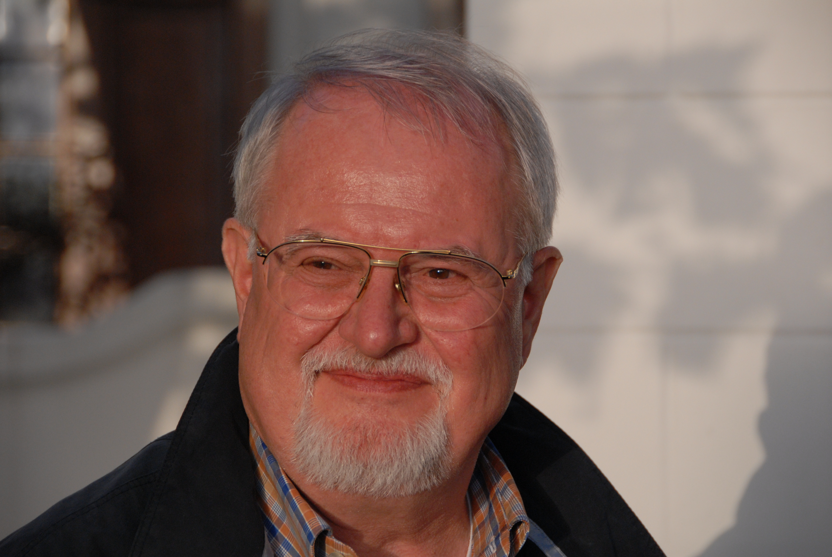
He was the founder of the German WGKT (Scientific Organisation of Hospital Engineering) and assumed great responsibility as its President for 30 years. After his presidency he was elected Honorary President of WGKT. During his presidency he was also a council member of the IFHE, the International Federation of Hospital Engineering.

All of us at WGKT and IFHE share a great sadness that our college and friend Christoph passed away. We highly enjoyed and valued meeting him on numerous occasions. His professional standing enabled him to make an important contribution to healthcare engineering nationally and internationally.

His presentations were outstanding and unforgettable: highly informative and presented in a convincing and professional manner, combined with a well pointed humor. Of great importance was also his calming influence and his willingness to contribute from his vast wealth of knowledge in healthcare from buildings to medical procedures and medical equipment.

His vision of our organization and his ambition to achieve a position that allows us to influence on an international level, particularly in Germany and Europe with respect to political, economical and technical decisions was an important factor in the establishment of the IFHE Europe.

The death of Professor Dr. Christoph Hartung is a great loss for all of us and especially for those who study, research and work with healthcare engineering. He was an outstanding character and personality with profound knowledge and experience that could always be referred to. He will be missed greatly.

In remembrance for his great commitment and in dedication to the benefit of healthcare engineering we will preserve an honour-filled memory of Christoph Hartung, a great person and scientist.

Christian Bender
on behalf of WGKT and IFHE

CONGRESS OPENING

On behalf of the International Federation of Hospital Engineering I congratulate my friend Dowe Kiestra for this successful event . I think that NVTG has done an excellent job and thinking of all of us has programmed an interesting Congress, surrounded by lights and a futuristic scenery.
On the other hand, The Netherlands, showing once again their traditional hospitality, offer a variety of good architecture in a balance of humanized environmental solutions together with cutting edge technology . Their proposals for elderly and disabled people are famous all around the world and good examples to be considered.
I trust that Dowe, as the new IFHE President for the period 2016-2018, will face an important challenge, encouraging new projects, reaching far away countries, and deepening the multidisciplinary dialogue.
I invite all of you to participate in the Working Groups of the Federation, opening the dialogue and intensifying the exchange between regions and disciplines for the benefit of our Hospitals and Healthcare in general.
Enjoy your time!

PRESENTATION AT COUNCIL MEETING
In the first place I want to express my gratitude to all the delegates that in the year 2010, in Japan, trusted Argentina, our young Association AADAIH, and me, as
an architect, to preside the Federation for the 2014-2016 period.
It has been a very interesting experience for me to exchange different matters with different people from different countries, and I hope have been useful to the IFHE.
My special gratitude to the team made up by Gunnar, Ronnie and Steve, who with the assistance of Annabelle have supported the actions of IFHE in this period.
I want to remark the important task developed by Andy Wavell and Francesc Castella, who through the IFHE DIGEST, IHEEM Journal and the Digital Library reach everybody in every country of this globalized world.
On the other hand, my mission in Latin America and in EXCO in general has been firmly supported by Fabio Bitencourt, Luciano Monza and Osvaldo Donato.
Christian Bender has collaborated promoting IFHE in Peru and other countries and supporting, together with IFHE, educational programs in Latin America.
For future times I may say that National Associations should have a stronger participation through academic and practical exchange, commercial firms and
Private or Public Institutions should be more involved supporting research and education.
I would also like to express my deep gratitude to former President Ole Rist, who preceded me and paved my way to the IFHE presidence.
I congratulate Prof. Nagasawa for his approach to China and India, and I wish a successful result in awakening interest in our global Institution.
I also congratulate Walt Vernon for starting with different proposals as an important contribution to Working Group 1, Environmental Policy and Sustainability. At this time I want to mention the agreement established with the WHO and the Global Green Healthy Hospital, and I hope that this kind of cooperation, with other international institutions has concrete results in the future.
I think that we need further contribution from European architects working in the Northern Hemisphere specialized in Healthcare facilities design, and from Latin American engineers and technicians, and from managers coming from all parts of the world working together in the different Groups.
I am sure that our friend Dowe Kiestra is a very active and open-minded person and will be able to achieve many of these objectives in the near future.
Liliana Font

Please join IFHE on Facebook www.facebook.com/groups/The IFHE

EVENTS CALENDAR
Please look IFHE webpage for updated information www.ifhe.info

EVENTS CALENDAR
IFHE members are invited to submit information regarding forthcoming events for publication.on www.ifhe.info

IFHE AND ‘A’ NATIONAL MEMBERS’ WEBSITES
Members are requested to keep IFHE informed about changes in contact details and website addresses.

A001 IHEEM UK www.iheem.org.uk A002 FENATO Italy www.usppi.info
A003 IHF France www.ihf.fr A006 NVTG Netherlands www.nvtg.nl
A007 ASHE USA www.ashe.org A008 NZIHE New Zealand www.nzihe.org.nz
A009 IHEA Australia www.ihea.org.au A010 SAFHE South Africa www.safhe.co.za
A012 VTDV Belgium www.VTDV.be A013 AEIH Spain www.aeih.org.
A014 IHS Switzerland www.ihs.ch A015 FSTA Denmark www.fsta.dk
A017 WGKT Germany www.wgkt.de A018 CHES Canada www.ches.org
A020 HEAJ Japan www.heaj.org A024 FKT Germany www.fkt.de
A025 AADAIH Argentina www.aadaih.com.ar A028 FSTL Norway www.fstl.org
A032 SUAIH Uruguay www.suaih.com.uy A033 UNAMHE Uganda www.unamhe.org
A035 ABDEH Brasil www.abdeh.org.br A038 AFHE Finland www.ssty.fi
A040 OVKT Austria www.oevkt.at A041 IHE India www.iheindia.org
A042 KIHA Korea www.ikiha.org A043 BEAM Malaysia www.beam.org.my
A044 SIAIS Italy www.siais.it IFHE www.ifhe.info
“Healthcare Engineering creating effective and efficient care world-wide“.

Your sincerely
Gunnar Baekken
IFHE General Secretary

